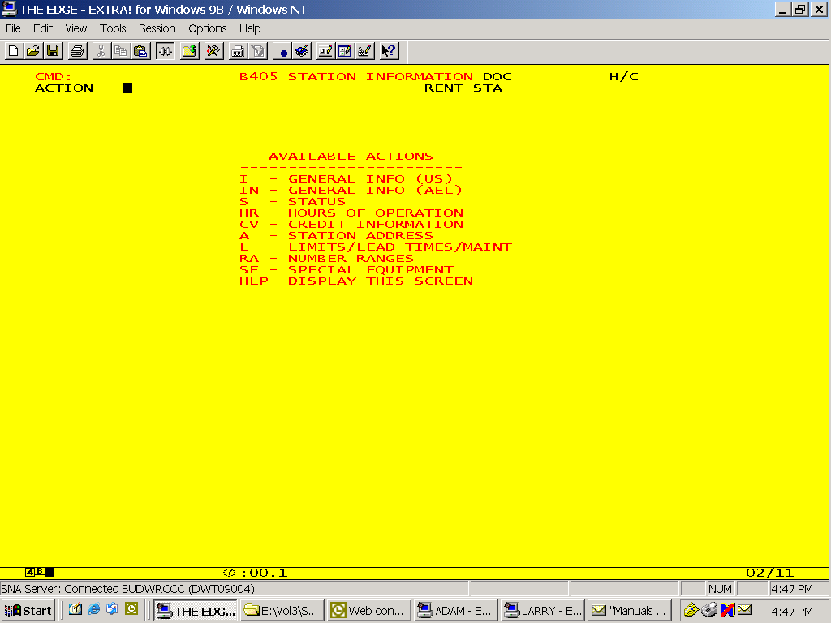

RENT STA = 4 digit Maestro station number –or- three character mnemonic (i.e. YVR, VO1, etc.)

